Modern History Book List
All of these books will be available to your student and some will be read out loud to your student in the course of their year diving into Modern History. All books listed are linked if you are looking to purchase for yourself (just click on the picture or title). This is a living list and will be added to continually as we find more great books to complement our learning.
This is a great way to build your own library!

- Story of the Reformation & Renaissance by Christine Miller
- The Awakening of Europe, by M.B. Synge (Yesterday’s Classics)
- The Struggle for Sea Power by M.B. Synge (Yesterday’s Classics)
- Growth of the British Empire by M.B. Synge (Yesterday’s Classics)
- All American History, vol. 2, student reader (only a few chapters to cover the 20th & 21st centuries – we’ll end at the Cold War or go through 9/11 & the war in Iraq, depending on where we are our last term)

Straight History
In the order that I found them on the shelves…
- Americans into Orbit: The Story of Project Mercury by Gene Gurney
- Story of Australia by Grove Day
- Tales from Scottish Grandfathers (4 volumes) by Sir Walter Scott
- George Washington’s World by Genevieve Foster
- Churchhill’s England by Adele Gutman Nathan

Biographies
- John Paul Jones by Evan Thomas
- Commandos of World War II by Hodding Carter
- David Livingstone by J.H. Worcester
- My Travels with Lewis and Clark by George Shannon
- Famous Men of Modern Times by John Haaren
- Presidents of the United States by David Williamson
- Kings and Queens of Britain Charles Phillips
- The Book of Heroes: Great Men and Women in American History by George Roche

The following are all linked (click the title) chapter books for the modern time period. All are appropriate for the 4th grade student. Below them is a list of picture books that would be appropriate for a younger sibling if you like to curl up on the couch!

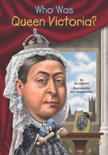
Who Was Queen Victoria?
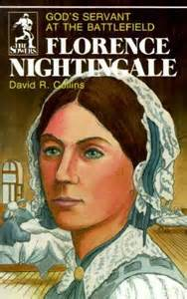
Florence Nightingale: God’s Servant at the Battlefields

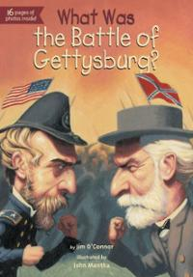
What Was the Battle of Gettysburg?
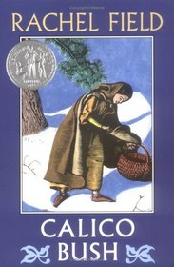
Calico Bush

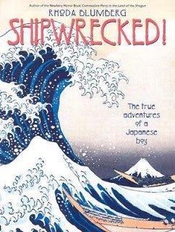
Shipwrecked! The True Adventures of a Japanese Boy
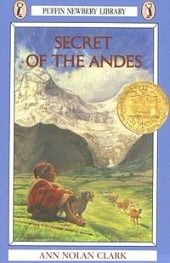
Secret of the Andes

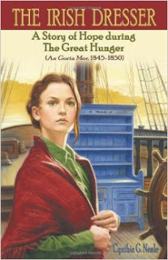
The Irish Dresser

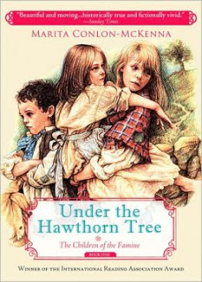
Under the Hawthorne Tree
A Single Shard

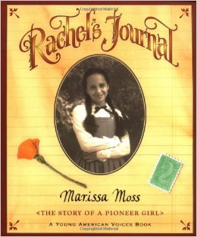
Rachel’s Journal

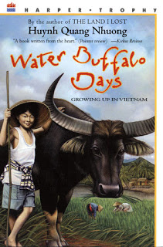
Water Buffalo Days
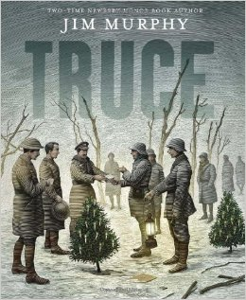
Truce: The Day Soldiers Stopped Fighting

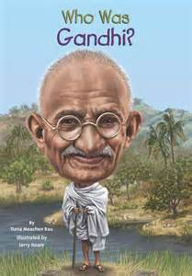
Who Was Gandhi?
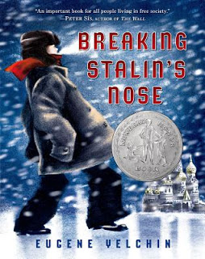
Breaking Stalin’s Nose
What Was the Great Depression?

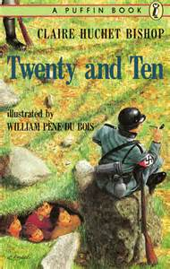
Twenty and Ten
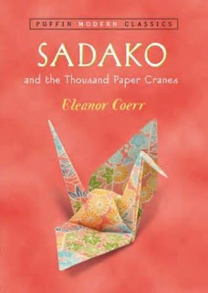
Sadako and the Thousand Paper Cranes
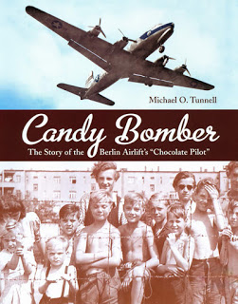
Candy Bomber

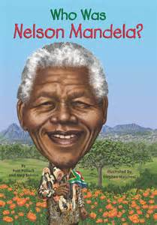
Who Was Nelson Mandela?
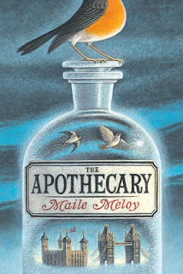
The Apothecary
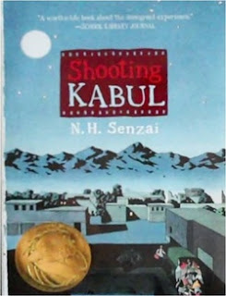
Shooting Kabul

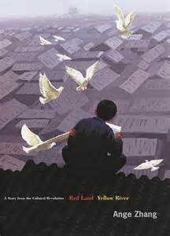
Red Land Yellow River
Modern Era Picture Books:

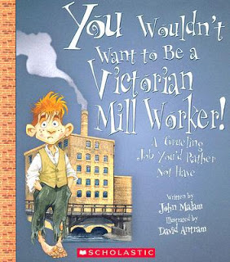
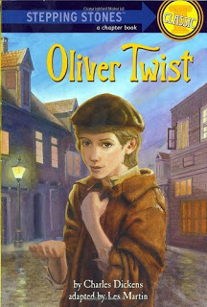
You Wouldn’t Want to Be a Victorian Mill Worker
Oliver Twist: A Stepping Stone Classic

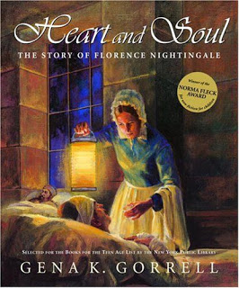
Heart and Soul: The Story of Florence Nightingale
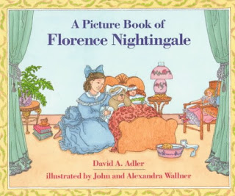
A Picture Book of Florence Nightingale

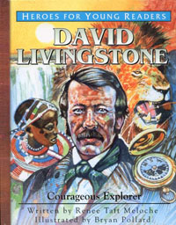
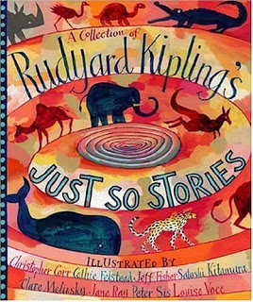
David Livingstone: Courageous Explorer
A Collection of Rudyard Kipling’s Just So Stories

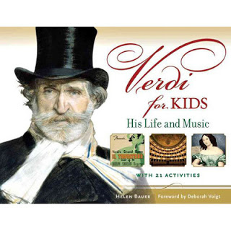
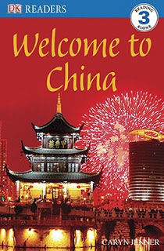
Verdi for Kids
Welcome to China

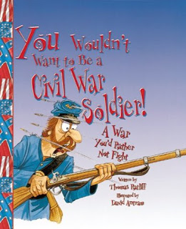
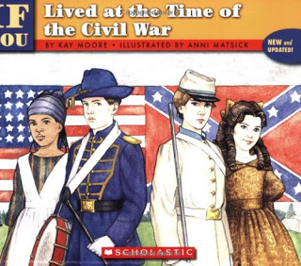
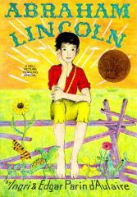
You Wouldn’t Want to Be a Civil War Soldier
If You Lived at the Time of the Civil War
Abraham Lincoln by Ingri d’Aulaire

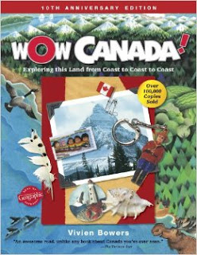
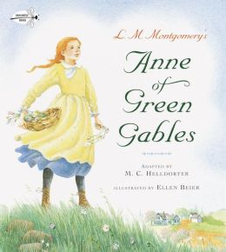
Wow Canada!
Anne of Green Gables by Helldorfer

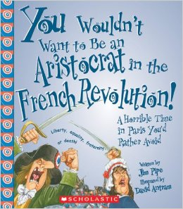
You Wouldn’t Want to Be an Aristocrat During the FrenchRevolution

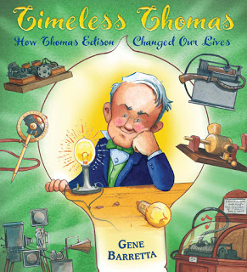
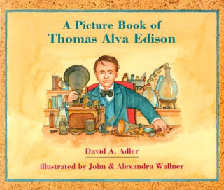
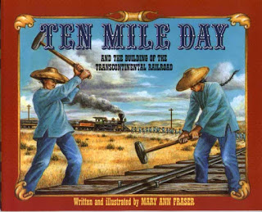
Timeless Thomas
A Picture Book of Thomas Alva Edison
Ten Mile Day

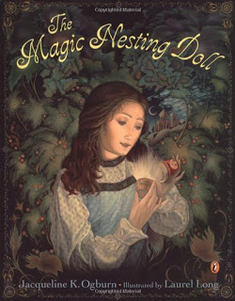
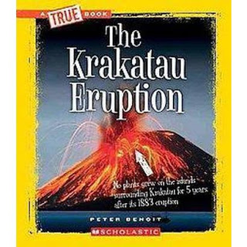
The Magic Nesting Doll
The Krakatau Eruption

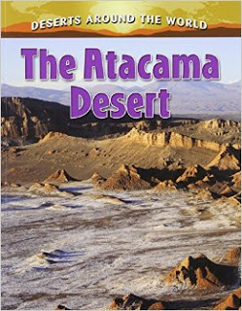
The Atacama Desert by Peppas

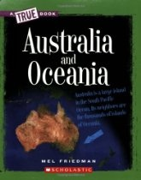
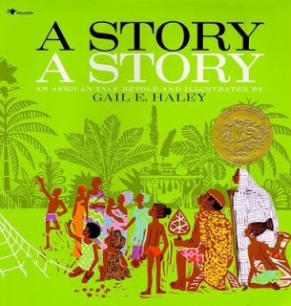
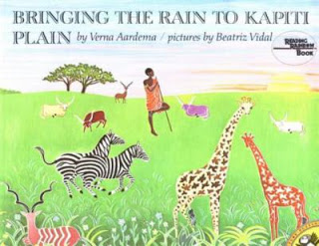
Australia and Oceania (True Books)
A Story, A Story by Haley
Bringing the Rain to Kapiti Plain

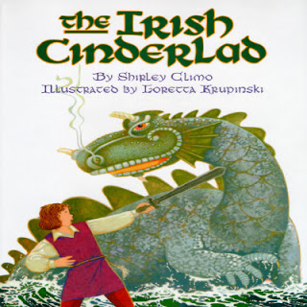
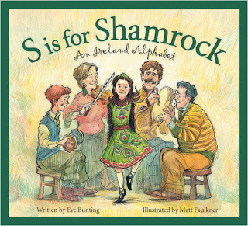
The Irish Cinderlad
S is for Shamrock

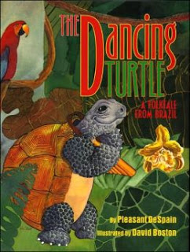
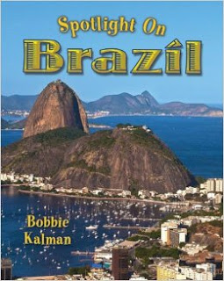
Dancing Turtle: A Folktale from Brazil
Spotlight on Brazil

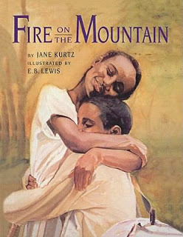
Simple History: The Russian Revolution
Fire on the Mountain by Kurtz

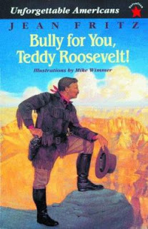
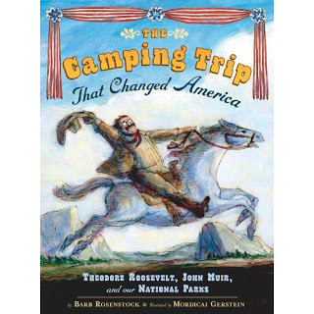
Bully for You Teddy Roosevelt
The Camping Trip that Changed America

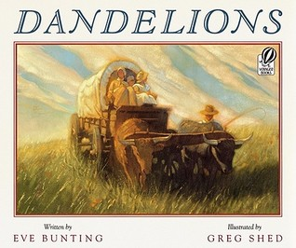
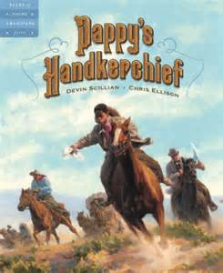
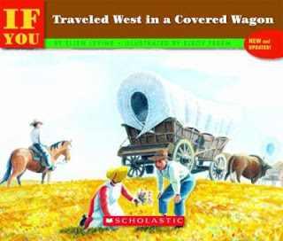
Dandelions by Bunting
Pappy’s Handkerchief
If You Traveled West in a Covered Wagon

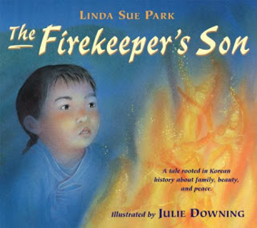
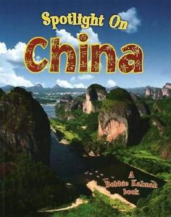
The Firekeeper’s Son
Spotlight on China

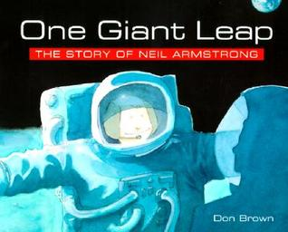
Finding Out About Coal, Oil, and Natural Gas
Saluki Hound of the Bedouin

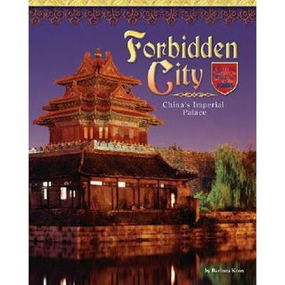
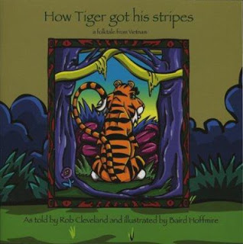
Forbidden City by Knox
How the Tiger Got His Stripes: A Folktale From Vietnam

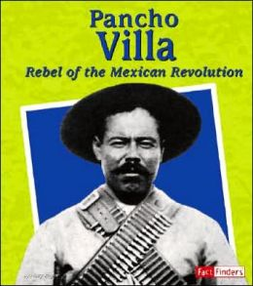
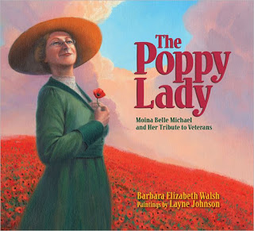
Pancho Villa: Rebel of the Mexican Revolution
The Poppy Lady

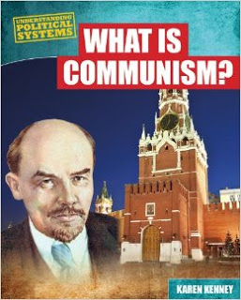
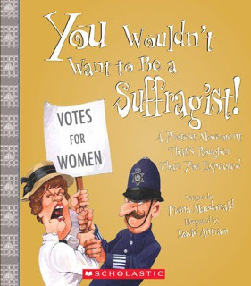
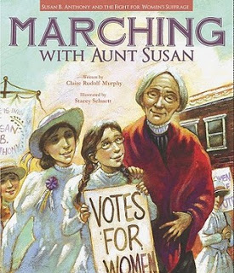
What is Communism?
You Wouldn’t Want to be a Suffragist
Marching with Aunt Susan

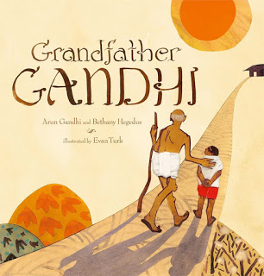
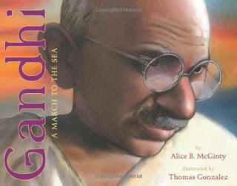
Grandfather Gandhi
Gandhi: A March to the Sea

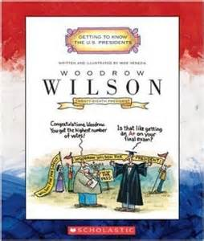
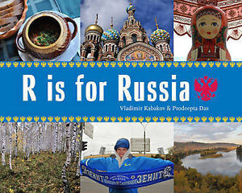
Woodrow Wilson by Venezia
R is for Russia

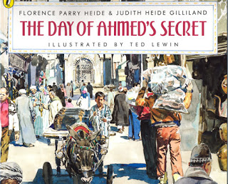
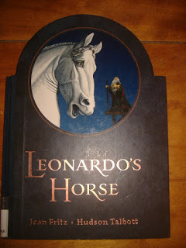
The Day of Ahmed’s Secret
Leonardo’s Horse

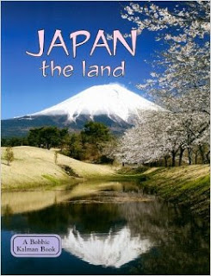
Japan the Land

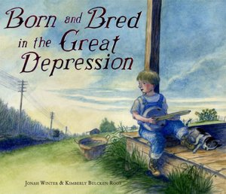

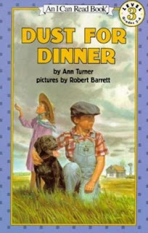
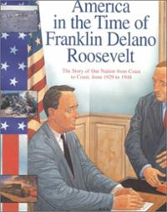
Born and Bred in the Great Depression
Dust for Dinner
America in the Time of Franklin Delano Roosevelt

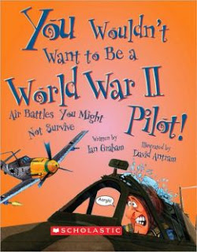
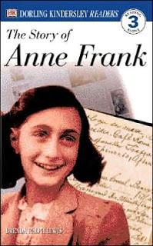
You Wouldn’t Want to Be a World War II Pilot
Lily’s Victory Garden
The Story of Anne Frank – DK Readers

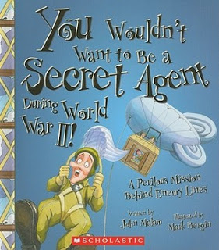
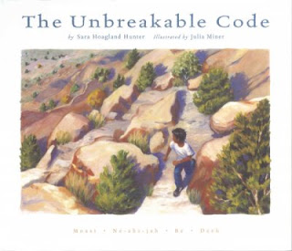
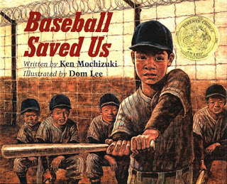
You Wouldn’t Want to Be a Secret Agent During World War II
The Unbreakable Code
Baseball Saved Us

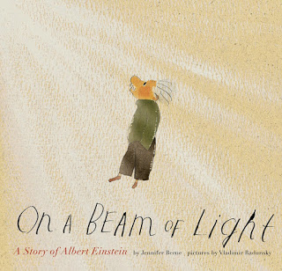
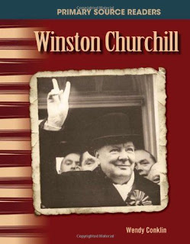
On a Beam of Light
Winston Churchill: The 20th Century

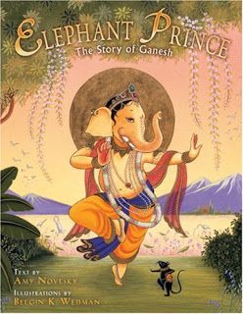
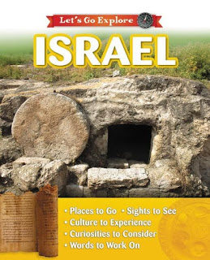
Elephant Prince
Israel: Let’s Go Explore

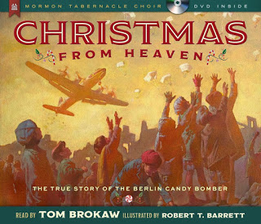
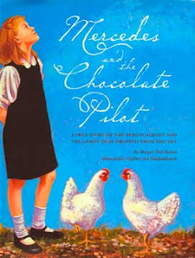
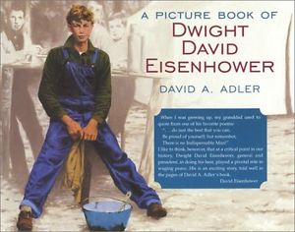
Christmas From Heaven
Mercedes and the Chocolate Pilot
A Picture Book of Dwight Eisenhower

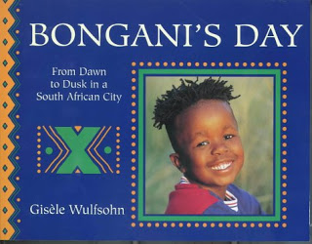
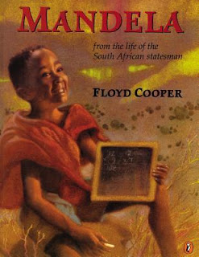
Bongani’s Day: From Dawn to Dusk in a South African City
Mandela: From the Life of the African Statesman

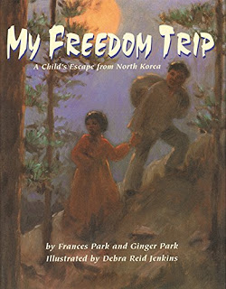
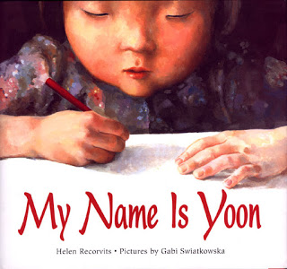
My Freedom Trip
My Name is Yoon

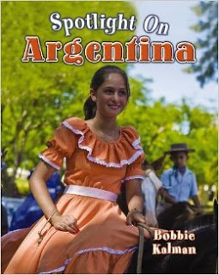
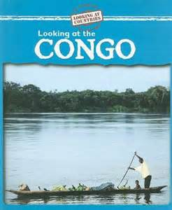
Spotlight on Argentina
Looking at the Congo

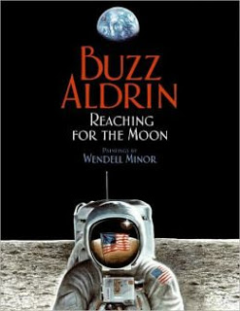
One Giant Leap: The Story of Neal Armstrong
Reaching for the Moon
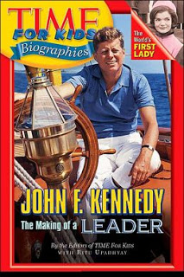
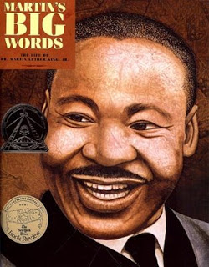
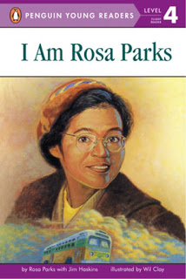
Time for Kids: John F Kennedy
Martin’s Big Words
I Am Rosa Parks
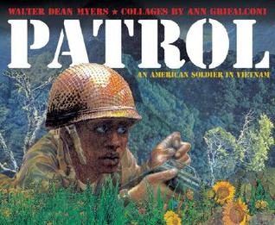
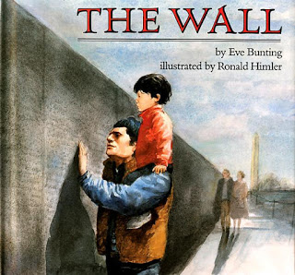
Patrol: An American Soldier in Vietnam
The Wall by Eve Bunting
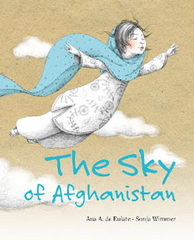
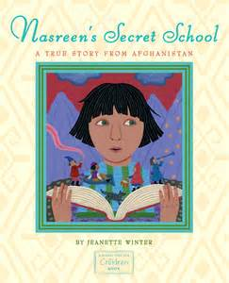
The Sky of Afghanistan
Nasreen’s Secret School
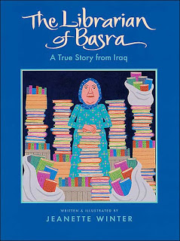
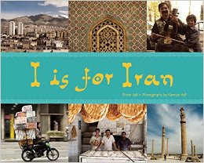
The Librarian of Basra
I is for Iran
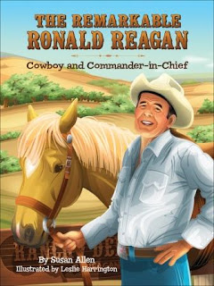
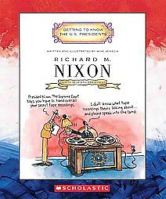
The Remarkable Ronald Reagan
Richard Nixon by Venezia
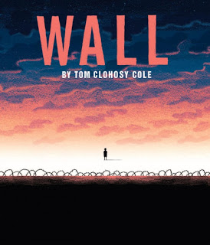
Wall by Tom Clohosy Cole
The Red Piano
The Persian Gulf War (We the People)

