Early Modern History Book List
All of these books will be available to your student and some will be read out loud to your student in the course of their year diving into Early Modern History. All books listed are linked if you are looking to purchase for yourself (just click on the picture). This is a living list and will be added to continually as we find more great books to complement our learning.
This is a great way to build your own library!

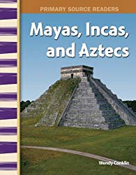
Mayas, Incas, and Aztecs: World Cultures Through Time
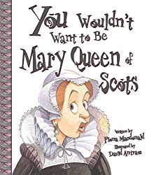
You Wouldn’t Want to Be Mary Queen of Scots!
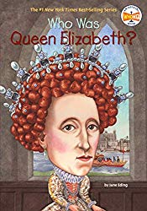
Who Was Queen Elizabeth?
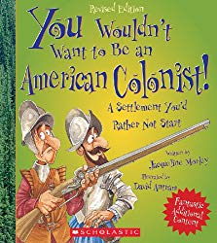
You Wouldn’t Want to Be An American Colonist
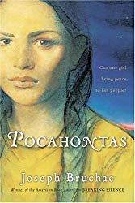
Pocahontas by Bruchac

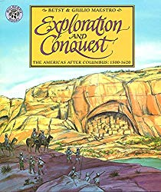
Exploration and Conquest
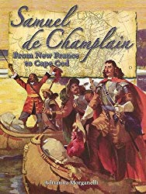
Samuel de Champlain by Morganelli

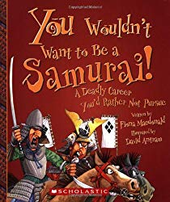
You Wouldn’t Want to be a Samurai
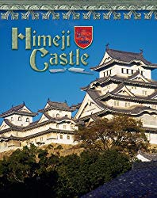
Himeji Castle by Ball

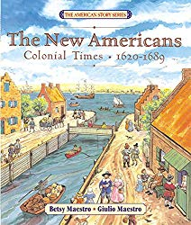
The New Americans: Colonial Times
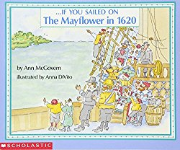
If You Sailed on the Mayflower…

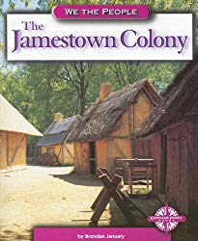
The Jamestown Colony
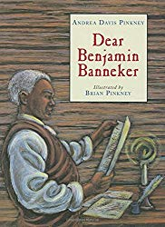
Dear Benjamin Banneker

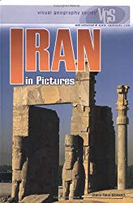
Iran in Pictures

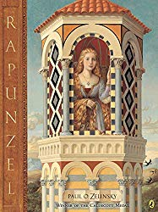
Rapunzel by Zelinsky
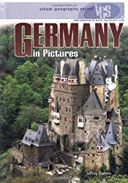
Germany in Pictures

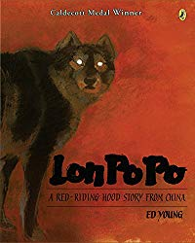
Lon Po Po: A Red-Riding Hood Story from China

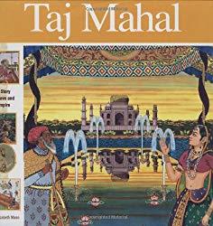
Taj Mahal: A Story of Love and Empire

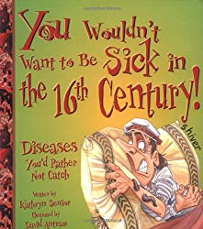
You Wouldn’t Want to be Sick in the 16th Century!

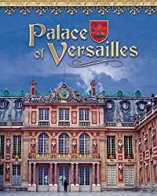
Versailles by Tagliaferro

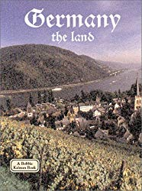
Germany the Land
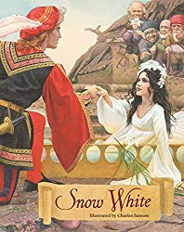
Snow White by Grimm
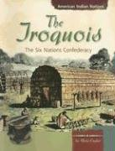
The Iroquis by Englar

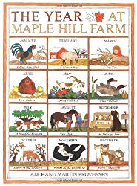
The Year at Maple Hill Farm
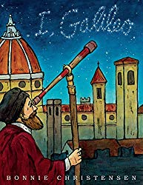
I, Galileo

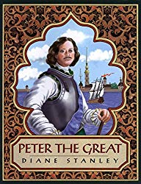
Peter the Great by Stanley
The Sea King’s Daughter: A Russian Legend

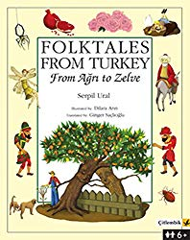
Folktales of Turkey from Agri to Zelve

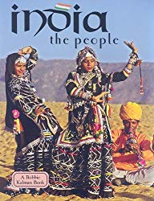
India the People by Kalman

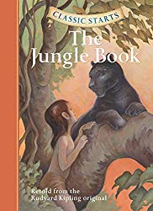
The Jungle Book Classic Starts

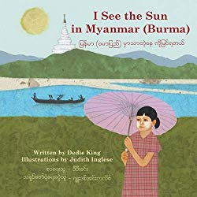
I See the Sun in Myanmar
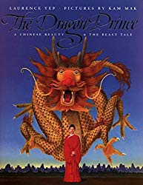
The Dragon Prince

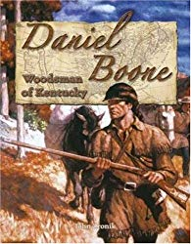
Daniel Boone: Woodsman of Kentucky
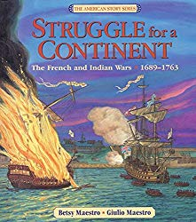
Struggle for a Continent
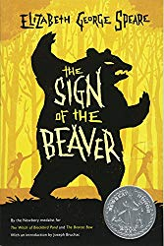
Sign of the Beaver

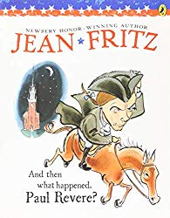
And Then What Happened Paul Revere?
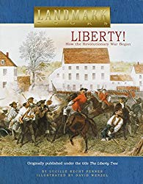
Liberty! How the Revolutionary War Began
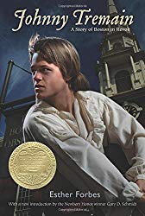
Johnny Tremain

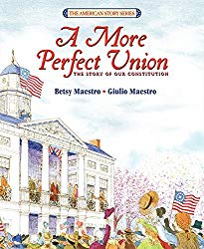
A More Perfect Union
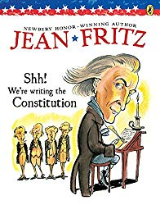
Shh! We’re Writing the Constitution
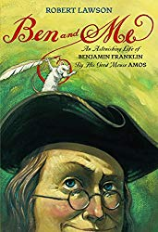
Ben and Me

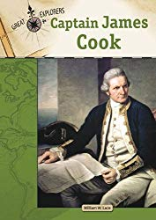
Captain James Cook (Great Explorers)
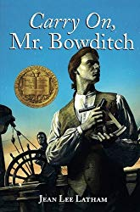
Carry on Mr. Bowditch

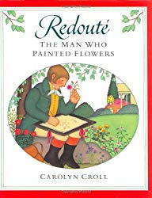
Redoute: The Man Who Painted Flowers

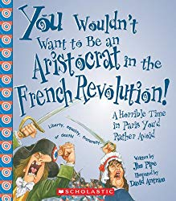
You Wouldn’t Want to be an Aristocrat in the French Revolution

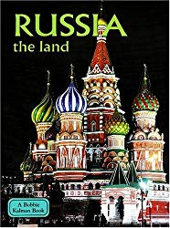
Russia the Land
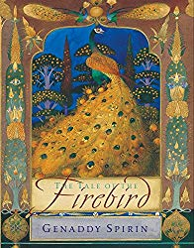
The Tale of the Firebird

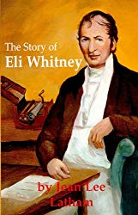
The Story of Eli Whitney
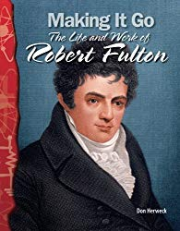
Making It Go: The Life and Work of Robert Fulton

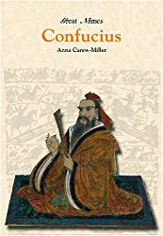
Confucius: Great Chinese Philosopher
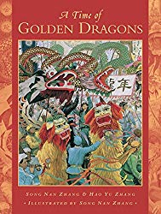
A Time of Golden Dragons

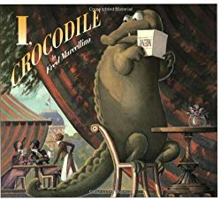
I, Crocodile
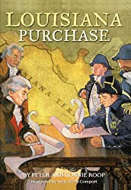
Louisiana Purchase by Roop

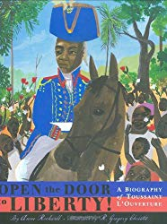
Open the Door to Liberty
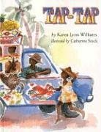
Tap, Tap

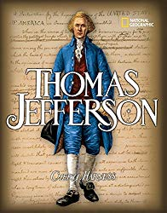
Thomas Jefferson by Harness
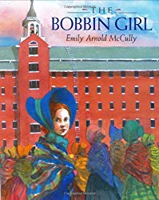
The Bobbin Girl

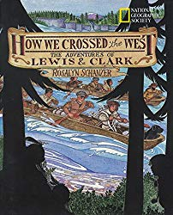
How We Crossed the West
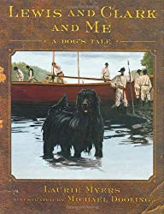
Lewis and Clark and Me

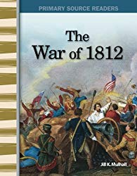
The War of 1812 by Mulhall
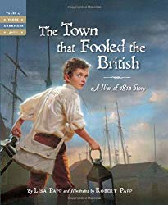
The Town that Fooled the British
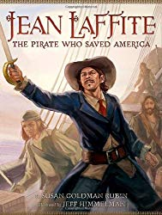
Jean Lafitte: The Pirate Who Saved America

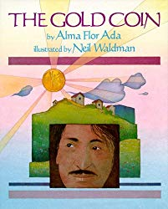
The Gold Coin
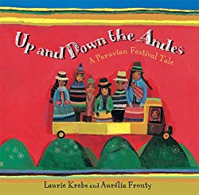
Up and Down the Andes

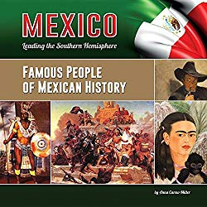
Famous People of Mexican History
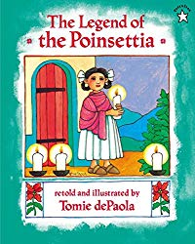
The Legend of the Poinsettia

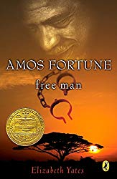
Amos Fortune Free Man
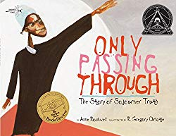
Only Passing Through
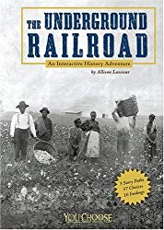
The Underground Railroad by Lasseiur

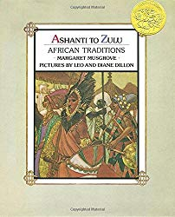
Ashanti to Zulu
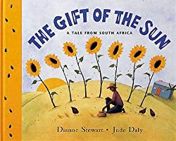
The Gift of the Sun

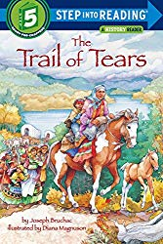
Trail of Tears by Bruchac
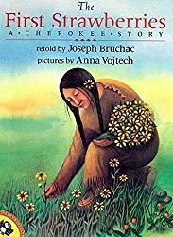
The First Strawberries

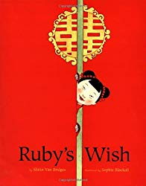
Ruby’s Wish

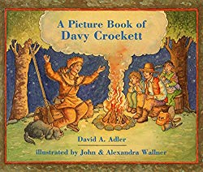
A Picture Book of Davy Crockett
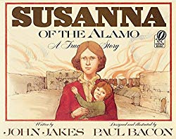
Susanna of the Alamo
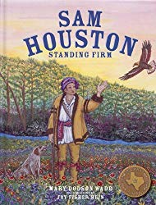
Sam Houston: Standing Firm
New Zealand ABC’s
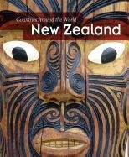
New Zealand by Colson

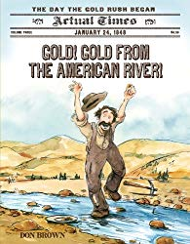
Gold! Gold from the American River!
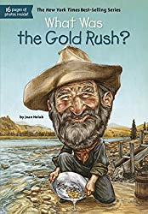
What Was the Gold Rush?

Sir Walter Ralegh and the Quest for El Dorado by Marc Aronson
Who Was Queen Elizabeth?
Where is the Taj Mahal
Black Powder by Ally Sherick
I, Juan de Pereja by Elizabeth Borton De Trevino
Witch Hunt: It Happened in Salem Village (Step into Reading)
Witch of Blackbird Pond by Elizabeth George Speare
Carry on Mr. Bowditch by Jean Lee Latham
Amos Fortune, Freeman by Elizabeth Yates
Who Was Marie Antoinette?
Shadow of the Bull by Maia Wojciechowska
Commodore Perry in the Land of the Shogun by Robin Blumberg
Ned: Barnardo Boy by Barbara Coyle
The Shakespeare Stealer by Gary Blackwood
Mary, Queen of Scots: Queen Without a Country, France 1553 by Kathryn Lansky (for 7th grade)
Kristina: The Girl King, Sweden, 1638 by Carolyn Meyer
Johannes Kepler: Giant of Faith and Science By John Hudson Tiner
Isaac Newton: Inventor, Scientist, and Teacher by John H. Tiner The World of William Penn by Genevieve Foster (better fit for 7th grader)
The Ravenmaster’s Secret: Escape the Tower of London by Elvira Woodruff
Indian Captive: the story of Mary Jemison by Lois Lenski My Name is Not Angelica by Scott O’Dell (for older readers, 7th grade cycle)
The Stowaway: A Tale Of California Pirates by Kristiana Gregory
Woods Runner by Gary Paulsen
Betsy and the Emperor by Betsy Stanton (7th grader)
Stowaway by Karen Hess
The Broken Blade by William Durbin
Anna and the King by Margaret Landon

